**Georectifiction Procedures**

**Overview:**

These procedures will describe the steps to georectify scanned maps. The purpose of this procedure is to allow users to relate the cataloged maps to their real location on Earth (i.e. georectification) so that the resulting georectified maps can be overlaid in their correct geographic location using GIS software.

**Georectification procedures:**

1. To georectify a map in BandoCat:
2. Log into BandoCat: <http://cartogram.fw.tamucc.edu:81>
3. From the menu on the left of the screen go to GeoRectification, select either Blucher Maps, or Green Maps. This will open a Maps Georectification page. In this page the maps may be sorted by selecting up, or down arrows at the head any column.

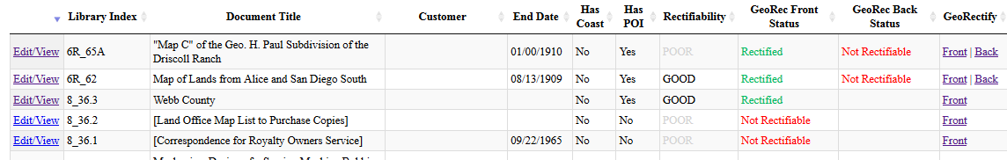

*Maps Georectification Page*

In the GeoRec Front Status and the GeoRec Back Status columns the maps are labeled as: **Rectified, Not Rectified, Research Required, or Not Rectifiable**.

1. At the bottom of the GeoRec Front Status column, select the dropdown box and choose **Not Rectified**.
2. Choose a map to rectify by clicking on **Front** or **Back** in the Georectify column on the row of the map to be rectified. BandoCat will display a message that it is generating map tiles which will take a few moments.

After generating the tiles, BandoCat will open a new Map Georeferencer window with the base map in the left pane and the raster map in the right pane.

**Note:** If you do not see the new window, you may have popups blocked in your web browser. Disable popup blocking and repeat the above step.

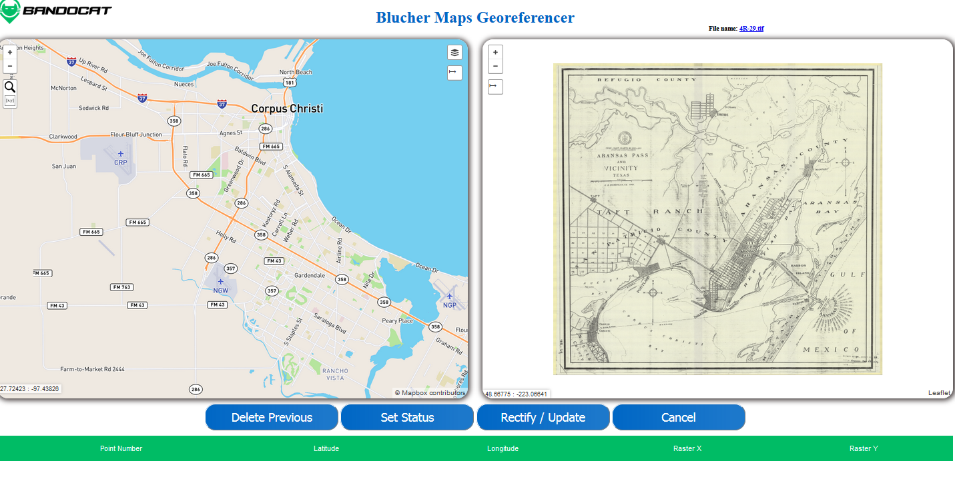

*Georeferencer Window*

**Choose a base map type**

There are two map types from which to choose in the base map window. To choose the map type, hover the mouse pointer over the Street/Satellite View icon at the top right of the screen. If details from a satellite image are useful choose the Satellite view and add street information by checking the Esri Transportation box. Street view offers a less cluttered map, which is useful for locating smaller towns, and street and railroad intersections.

To rectify the map, a minimum of three identifiable, corresponding points must be found and marked in each map. Street intersections, points of interest, structures, and stable natural features are typically good candidate points. Street intersections are the most common places to set a point marker, but depending on the scale of the map, identifiable land objects may be used. For example, in a map of the state of Texas the western tip at El Paso, the corners of the panhandle, the intersection of the panhandle and the Red River, and the Rio Grande at the Gulf of Mexico may be used.

To assist you in finding and marking locations on the map, review Appendix A to learn how to use the Address Locator tool, the Coordinate Entry Tool, and the Measurement Tool. Use of these tools are critical to maximizing the number of maps that can be georectified.

In addition to finding pairs of points on both maps, a good distribution of points is needed for a high-quality rectification. The figures below show an example of maps with poor and good point distribution. Sometimes it is not possible to have a good distribution of points, due to the nature of the location being mapped, however, a good distribution is always the goal, even if it takes additional time to determine points.

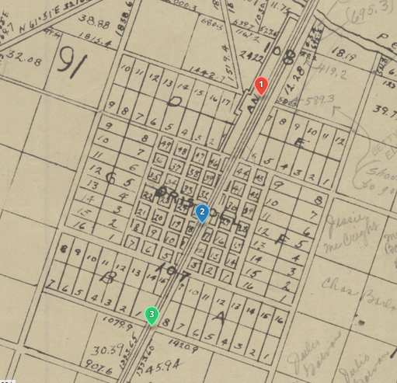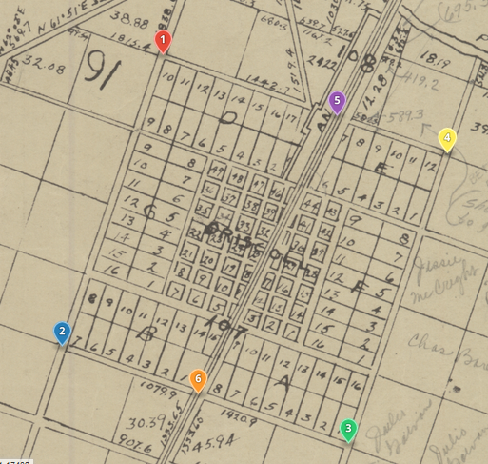

*Poor Distribution (Raster map) Good Distribution (Raster Map)*

1. Examine both maps to find suitable points.
   1. If you are unable to find suitable points then it is considered not rectifiable. Click the Set Status button located below the map panes. From the Update GeoRec Status drop down menu select **Not Rectifiable** then click Update. A pop up window will display “Status updated successfully!” Click OK and the Georeferencer page will close. The maps status will be changed to **Not Rectifiable**.
   2. If you are able to find suitable points, use the mouse crosshairs to mark the point in the raster pane by left-clicking the mouse, then mark the corresponding point in the base map pane by left-clicking the mouse.
2. Repeat the above step for the next pair of points. Each subsequent point must first be selected in the raster pane, then in the base map pane. As points are added to the panes the point numbers are added at the bottom of your screen showing the Latitude, Longitude, Raster X, and Raster Y for each point.
3. If marker points are chosen by mistake, or do not work in the rectification, the Delete Previous button will remove marker points in order from the most recent point selected to the first point selected.
4. When all the points have been marked, with proper distribution, click the Rectify/Update button located below the map panes.
5. When the map is rectified successfully a “Success” window will pop up. Click the OK button to close the Maps Georeferencer window. Then click the F5 button on your keyboard to refresh the page. At this point the map will be changed from **Not Rectified** to **Rectified**.

## Appendix A: Tools Available in BandoCat Georeferencer

BandoCat Georeferencer contains three tools aimed at assisting the user in finding locations (Address Locator Tool), entering coordinates (Coordinate Entry Tool), and measuring distances (Measurement Tool). This Appendix explains how to use each of these tools.

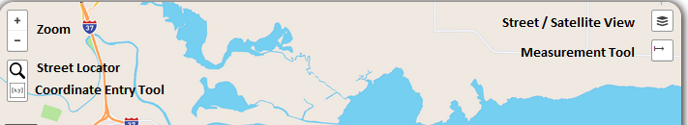

*Tool Icon Locations in Base Map Pane*

## Address Locator Tool

The address locator may be used to help locate a street or intersections on the base map. Using @ between two street names will search for the intersection of those two streets. Adding the city and state will narrow the search. To execute the search, press Enter on the keyboard. The base map will zoom to the street/intersection, or, the search tool will display a message saying that the address could not be found.

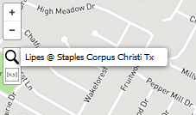

*Address Locator (Base Map)*

## Coordinate Entry Tool

Raster maps with latitude and longitude coordinates may have their corresponding points entered in the base map by using the coordinate entry tool ([x,y] icon) at the upper left of the base map, below the street search magnifying glass tool. After selecting an intersecting latitude and longitude in the raster map, click on the [x,y] icon in the base map, a popup box will ask you for the Latitude and then the Longitude, both in decimal degrees.

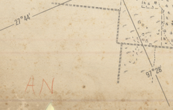 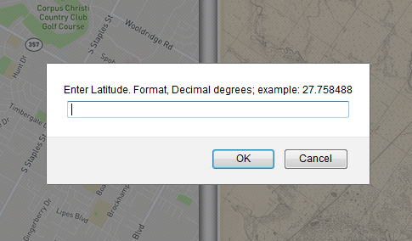

*Example of Coordinates on a Map Coordinate Tool Popup Box*

If maps in the collection have lines of latitude and longitude they will usually be in degrees and minutes, (ex. 27° 44”). Coordinates must be entered using decimal degrees.

To covert degrees minutes and seconds to decimal degrees:

Since there are 60 seconds in each minute, 27° 44' 17" can be expressed as 27° 44 17/60', or 27° 44.2833'.

Since there are 60 minutes in each degree, 27° 44.28333' can be expressed as 27 44.28333/60° or, 27.7380555°. Six decimal places gives an accuracy of approximately 0.11 m.

**Note:** In some cases entering latitude and longitude coordinates does not work, in which case the point values for Raster X and Raster Y at the bottom of the screen will display undefined values.



If you try to Rectify/Update after entering undefined values you will see “Warp Failed”, instead of “Success”. After clicking OK the window will close and the map will remain **Not Rectified**.

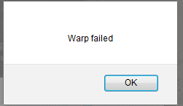

## Measurement Tool

Some maps do not have enough identifiable streets, or intersections, to place enough marker points for rectification. If there are bearings and distance on the raster map, the measurement tool enables the user to measure from a known point and add marking points on the base map by using the distance and bearings shown on the raster map. To learn more about Bearings vs. Azimuth, visit Appendix C.

1. Enable the measurement tool by left-clicking on the measurement tool icon. The icon background will change to green indicated that it is enabled.
2. With the measurement tool enabled, the user can left-click the mouse on the base map to select a beginning point, leaving a green node. As the crosshair moves across the screen the distance and bearing from the beginning node is displayed next to the crosshair. Left click a second time and the tool will leave an orange node and the distance and bearing between the two nodes. If you wish to continue to another point the display box will include the bearing and distance from the last point, in black numbers, and the total distance from the beginning node in green numbers.
   1. **Note:** To make multiple measurements without turning the tool off press the Escape key on the keyboard to leave each measurement, with a green to a red node, and its distances and bearings displayed on the screen.
3. Disable the tool by left-clicking on the measurement tool icon to stop measurements and clear the nodes from base map.

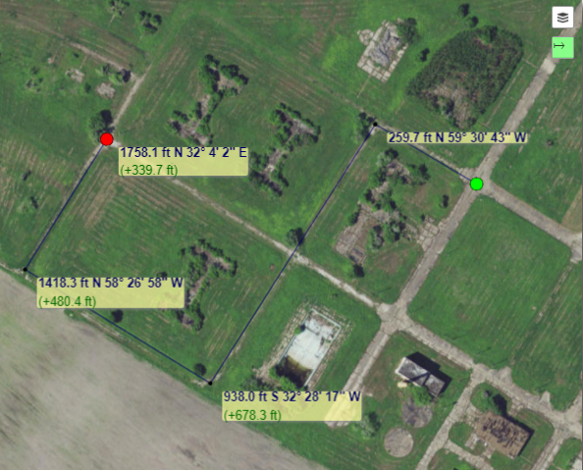 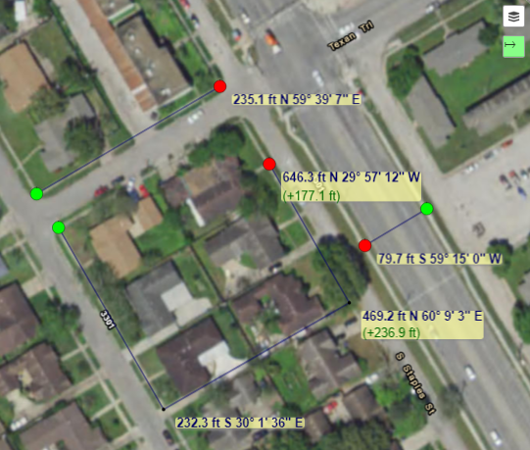

*Measurement Tool Used on Base Map* Example of *Multiple Measurements*

## Appendix B: Quality Control – How to check the Georectification Quality

A check of the rectification can be made by opening the map in Google Earth.

1. From the Maps Georectification page click **Edit/View** in the first column of the map row of the map you wish to check. This opens the associated Maps Review Form page.
2. At the bottom of the Maps Review Form page click on **Front KMZ**. Make sure that Open with Google Earth is selected in the pop up window, then click OK.

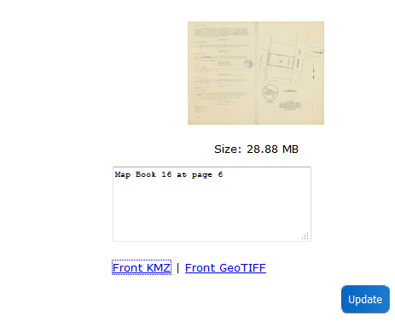 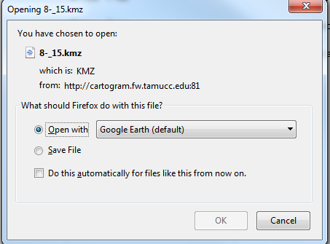

*Bottom of the Maps Review Form Pop up window After Clicking* Front KMZ

1. When Google Earth opens the raster map should be overlaid, and rectified to, the Google Earth map. When finished viewing the map close Google Earth and choose “Discard” from the pop-up window.

If the raster map does not align with the Google Earth map there might be a problem with point distribution, a lack of sufficient points to rectify the map, or a simple blunder in placing the marker points.

1. To redo a rectified map:
2. Return to the Maps Georectification page and select the map by clicking on **Front**, or **Back** in the Georectify column on the row of the map to be rectified.
3. To try rectifying again remove the marker points by using the Delete Previous button below the map panes to remove marker points in order from the most recent point selected.
4. Begin again by selecting marker points.
5. After the map has been rectified check it again in Google Earth.
6. If there is still a problem, or issue with the map rectification that cannot be solved:
7. Return to the Maps Georectification page and select the map again by clicking on **Front**, or **Back** in the Georectify column on the row of the map to be rectified.
8. Remove the marker points by using the Delete Previous button below the map panes to remove marker points until all of the points are removed from both the raster map and the base map.
9. After the marker points are removed click the Set Status button. If you are sure the map cannot be rectified select **Not Rectifiable** from the drop down menu and click the Update button. If there is still a possibility that the map can be rectified select **Research Required**, from the drop down menu then click the Update button.
10. Click the F5 button on the keyboard to refresh the page.
11. Make a note of the library index of any map that has undefined raster points, Translate failed, or Warp failed, and notify your supervisor so it may be reviewed.

## Appendix C: Bearings vs Azimuth

An azimuth is a horizontal angle measured clockwise from North, 0° to 360°. Southeast is written 135°.

A bearing is described from North or South, with the angle to the West or East. An azimuth of 135° would be written as a bearing of S 45° E, which can be thought of as: from the south (180°), 45° east.

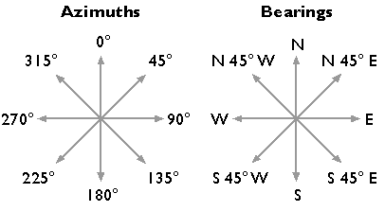 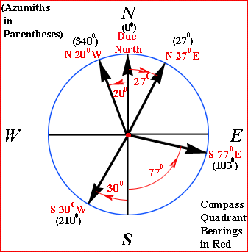

The collection maps measurements are usually given in Bearing and Distance, as in the example below.

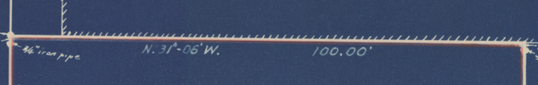

Most distances are in feet, but others are in varas and will need to be converted before using the measurement tool. 1 vara = 33 1/3 inches. To convert varas to feet take the varas and divide by 0.36.